Lab 2 TCP Attacks and Detection
Network Security (50.020) | Timothy Seah | Student ID 1007654 | Experiment: 1 October 2026
node1 client 10.11.2.5, node2 server 10.11.2.6, and node3 attacker 10.11.2.7.

1. Network and basic operations
Figure 1 records the IP addresses of all three nodes. Node2 reached node1 and node3 without packet loss, and Wireshark captured network traffic. Figure 2 shows the three containers running.
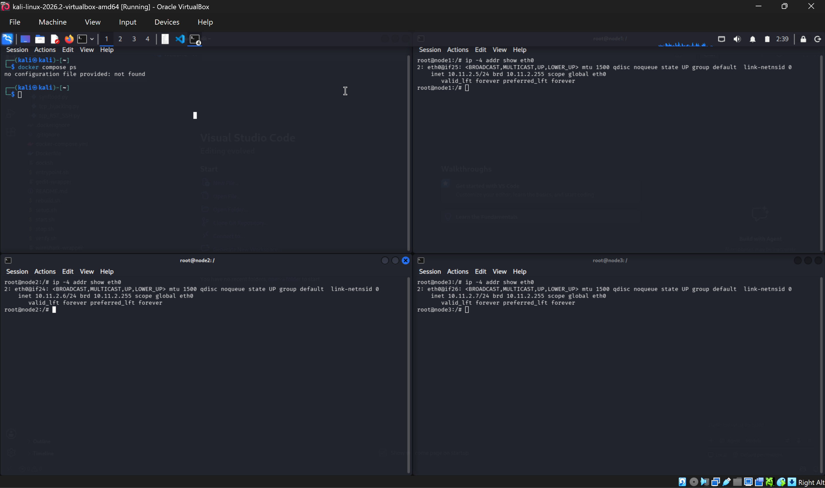  node1 10.11.2.5 | node2 10.11.2.6 | node3 10.11.2.7
Figure 1. IP addresses checked on node1, node2, and node3.
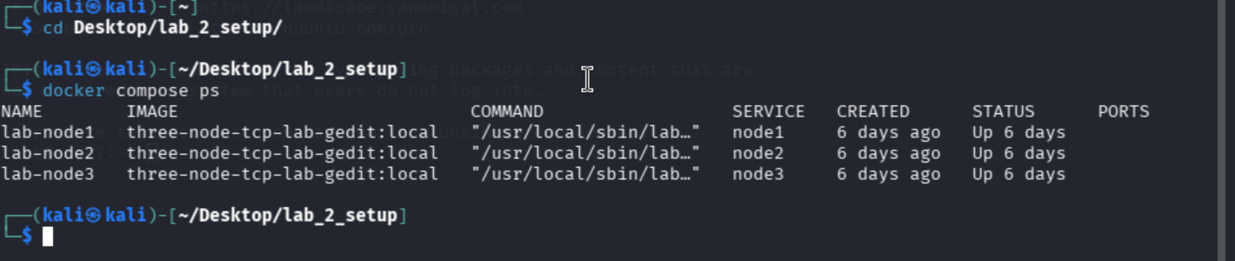
Figure 2. Docker Compose lists node1, node2, and node3 as running.

2. TCP SYN flooding

Parameters and method
Parameter | Node2 value shown | Purpose
tcp_max_syn_backlog | 128 | Limits pending connection requests before the handshake completes
tcp_syncookies | 0 initially | When enabled, SYN cookies help the server respond under SYN-queue pressure without retaining pending state for every request
tcp_synack_retries | 5 | Controls how many SYN-ACK retries are sent while awaiting the final ACK

At baseline, node2 showed tcp_max_syn_backlog=128, tcp_syncookies=0, and tcp_synack_retries=5. The Kali host readings were 256, 1, and 5 respectively. The host allowed a larger pending queue and had SYN cookies enabled, while both systems used five SYN-ACK retries.
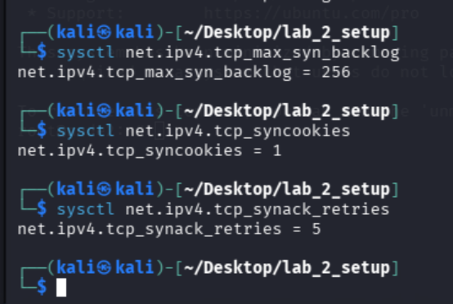
Figure 3. Kali-host TCP values used for comparison with node2.
A normal Telnet connection completed the SYN, SYN-ACK, ACK handshake. After closing it, I ran ip tcp_metrics flush to clear stored information about previous connections to the peer. This made the next run easier to compare but did not clear the SYN backlog.
In the first flood run, node3 sent SYN packets to Telnet port 23 from changing spoofed addresses without completing the handshakes. Node2 recorded 97 connections in SYN-RECV. Node1 retransmitted its SYN four times before receiving a SYN-ACK, then completed login. The flood delayed this connection but did not cause a sustained outage.

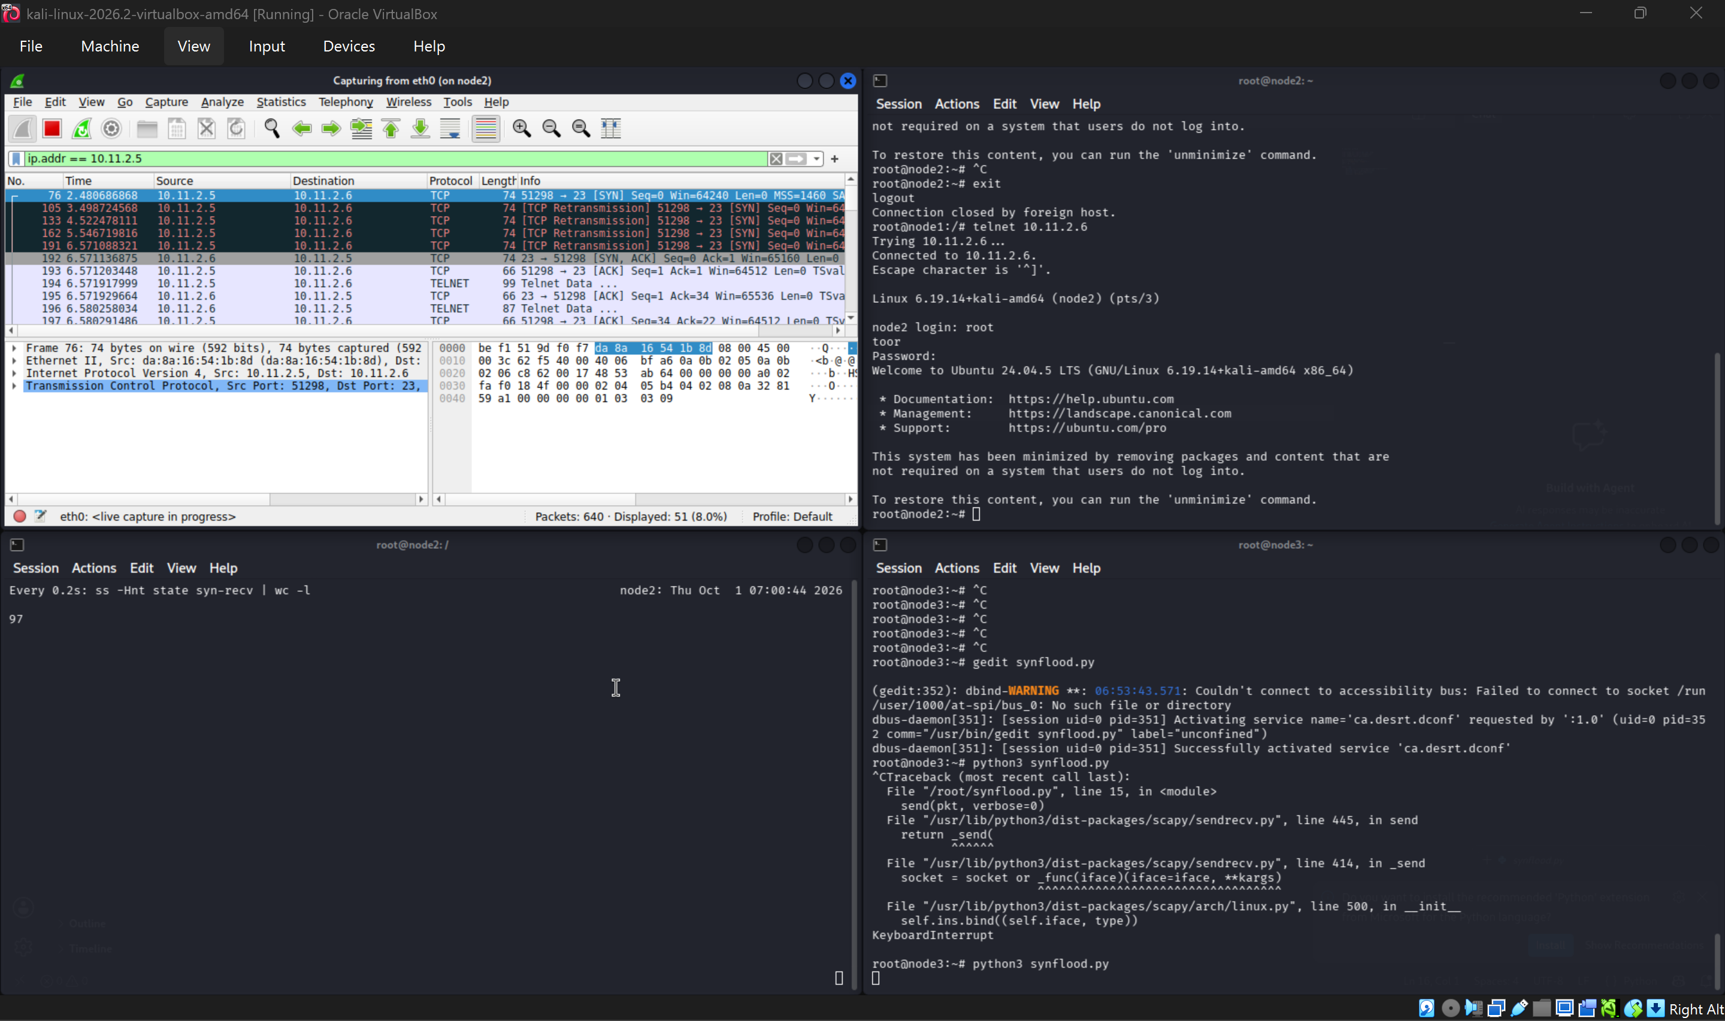
Figure 4. Node1 retransmitted its Telnet SYN four times during the flood.
A later capture from all three nodes shows the traffic from each position. Node3 recorded SYN packets with changing spoofed source addresses sent to node2:23. Node2 captured those SYNs alongside node1's Telnet traffic. Node1 captured its own Telnet handshake, which completed in that run. The earlier run above shows the connection delay.
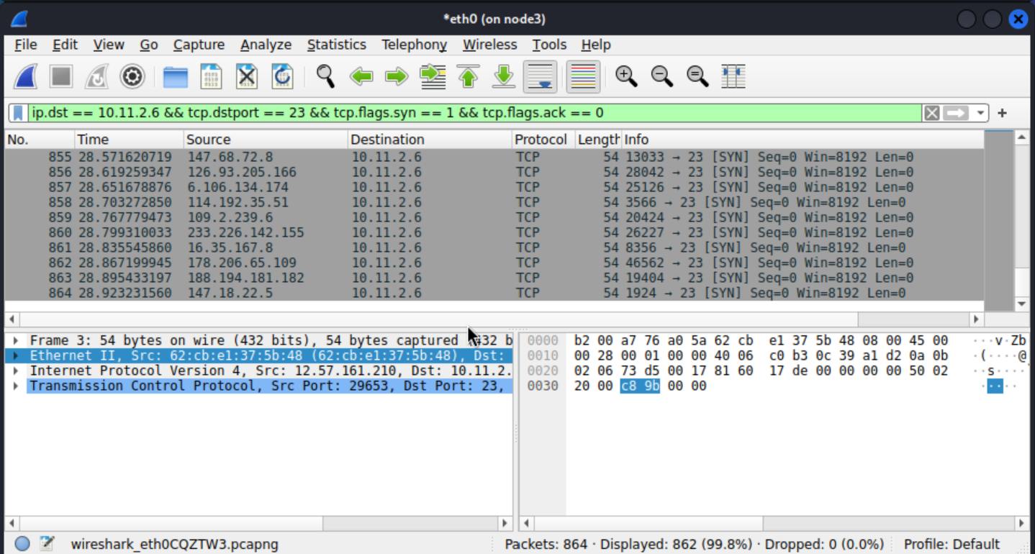
Figure 5. Node3 sends SYN packets to node2:23 with changing spoofed source IPs.
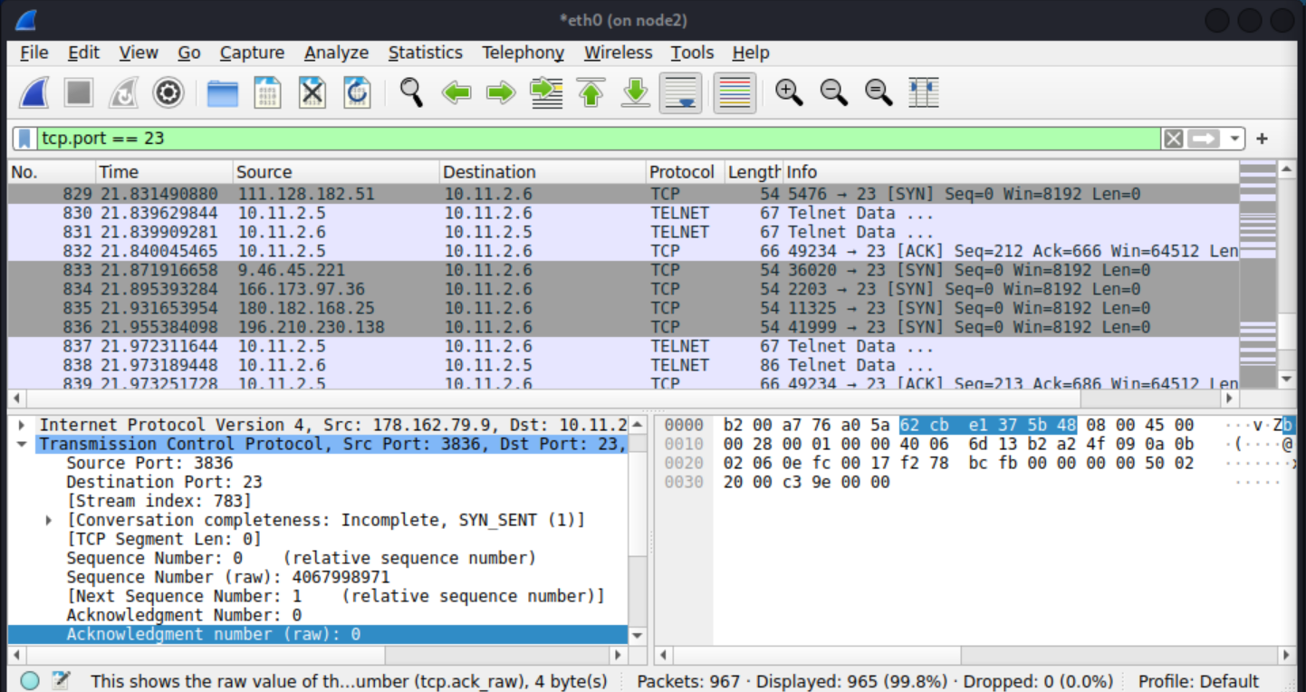
Figure 6. Node2 captures spoofed SYNs and node1's Telnet traffic.
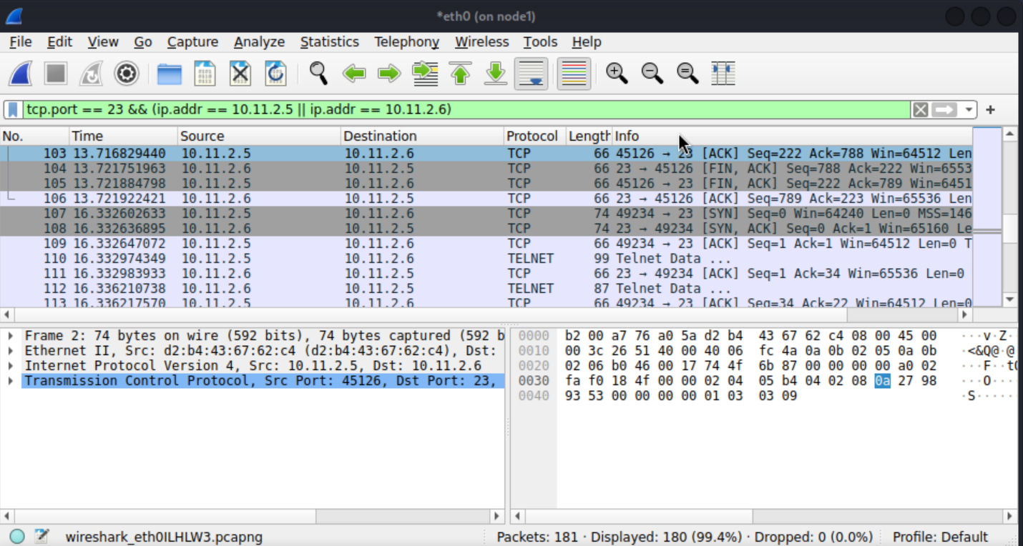
Figure 7. Node1 captures its own Telnet handshake in the later run.

Mitigation
On node2, net.ipv4.tcp_syncookies was changed from 0 to 1 and read back as 1 (Figure 8). During a renewed flood, the half-open count shown reached 127. Node1 completed a new Telnet handshake and login (Figure 9), showing that the service remained available in this run.
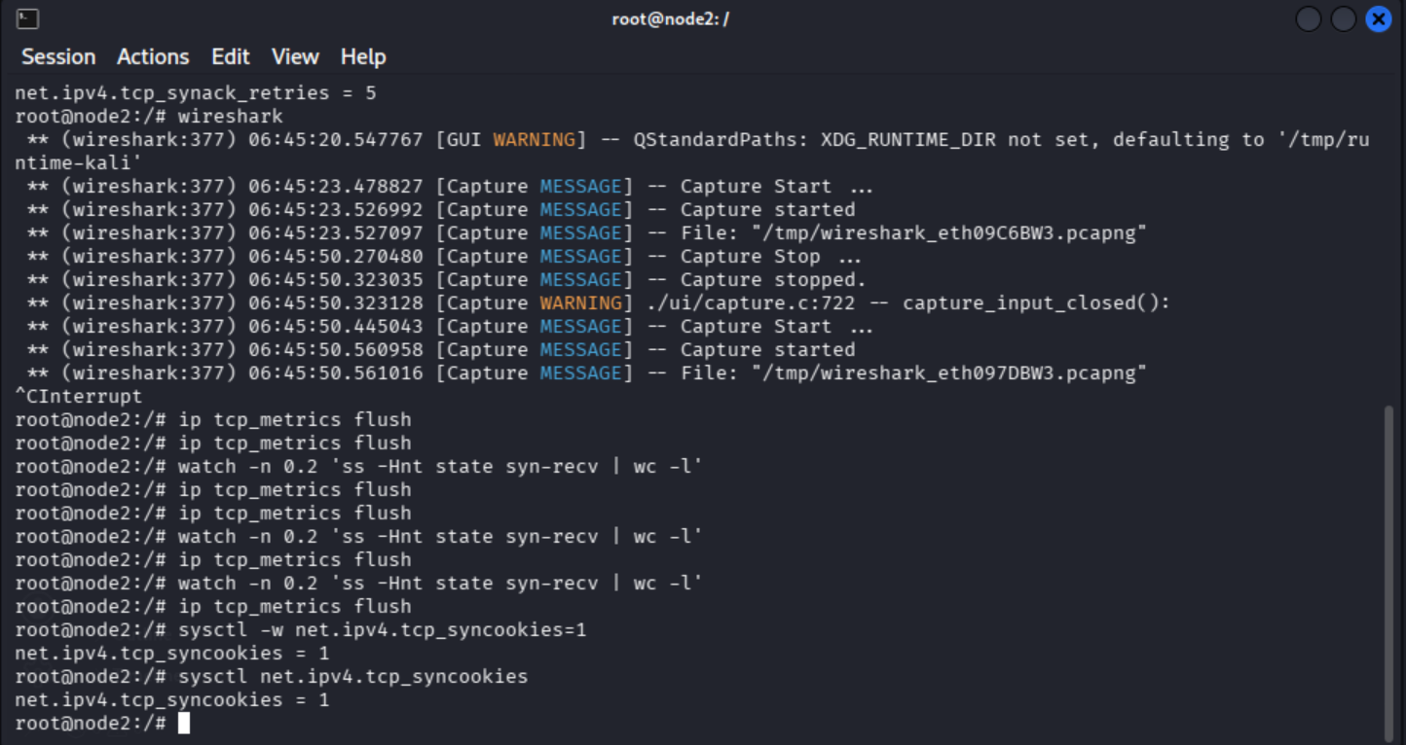
Figure 8. SYN cookies enabled and verified on node2.
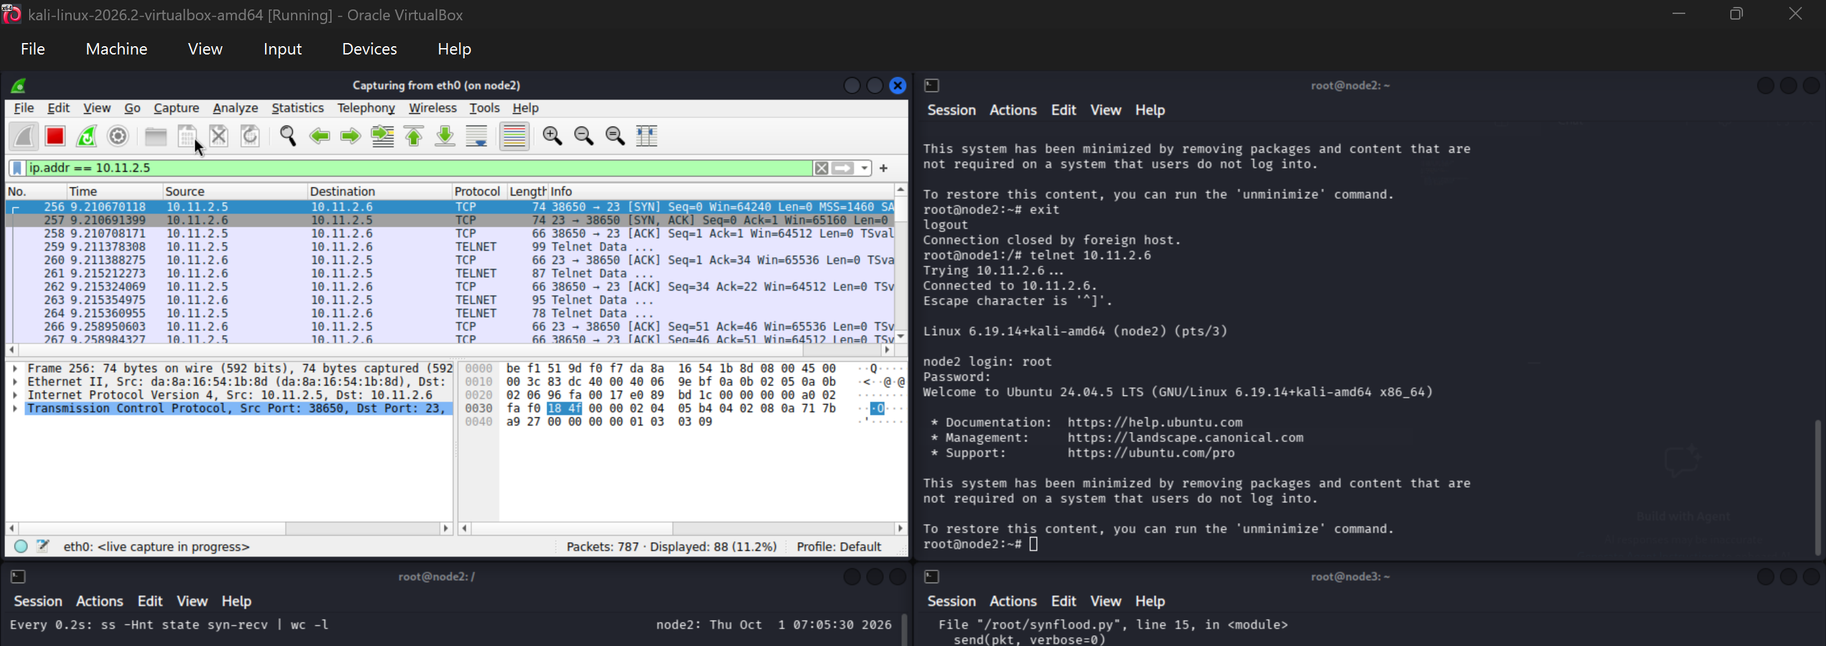
Figure 9. Node1 completes Telnet login while the renewed flood runs.

3. TCP reset attack
For the active SSH flow, node3 forged a packet claiming source 10.11.2.5:51458 and destination 10.11.2.6:22, with RST set and raw TCP sequence 2264913361 (relative sequence 4128). Wireshark captured a forged RST matching the SSH session’s addresses and ports, with a sequence number the receiver would accept. The packet had no ACK flag or payload, and node1’s SSH client reported “Broken pipe”.
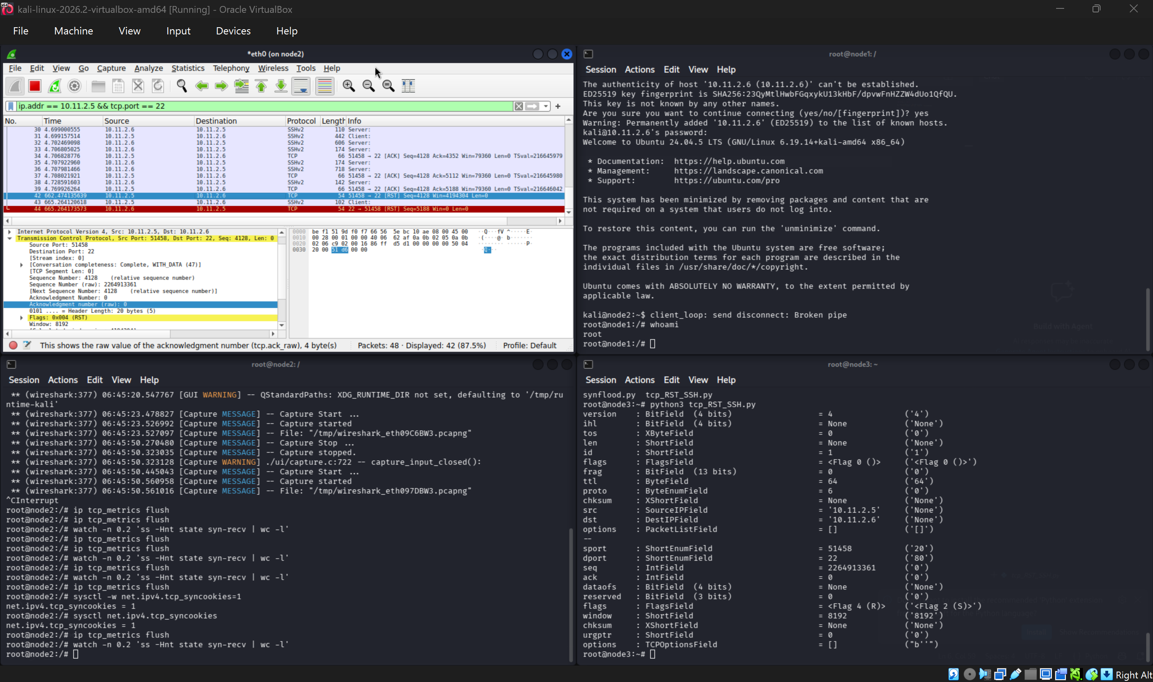
Figure 10. Forged RST in the SSH flow and the client disconnected.
An attacker restricted to node3 could still spoof an IP packet, but an external attacker may not know the live client port and next sequence number. They would need visibility into the session or another way to infer those values. Simply knowing the two IP addresses is insufficient.

4. TCP session hijacking
While node1’s root Telnet session was open, node3 sent a forged PSH, ACK packet to node2 on the same connection (10.11.2.5:42420 → 10.11.2.6:23). It used the observed raw sequence number 636491331 and acknowledgment number 17698764, with touch /root/log.txt\r\n as its 21-byte payload. Node2’s relative acknowledgment moved from 208 to 229, and /root/log.txt appeared. The server’s later retransmissions suggest the two endpoints had fallen out of sync after the injection.
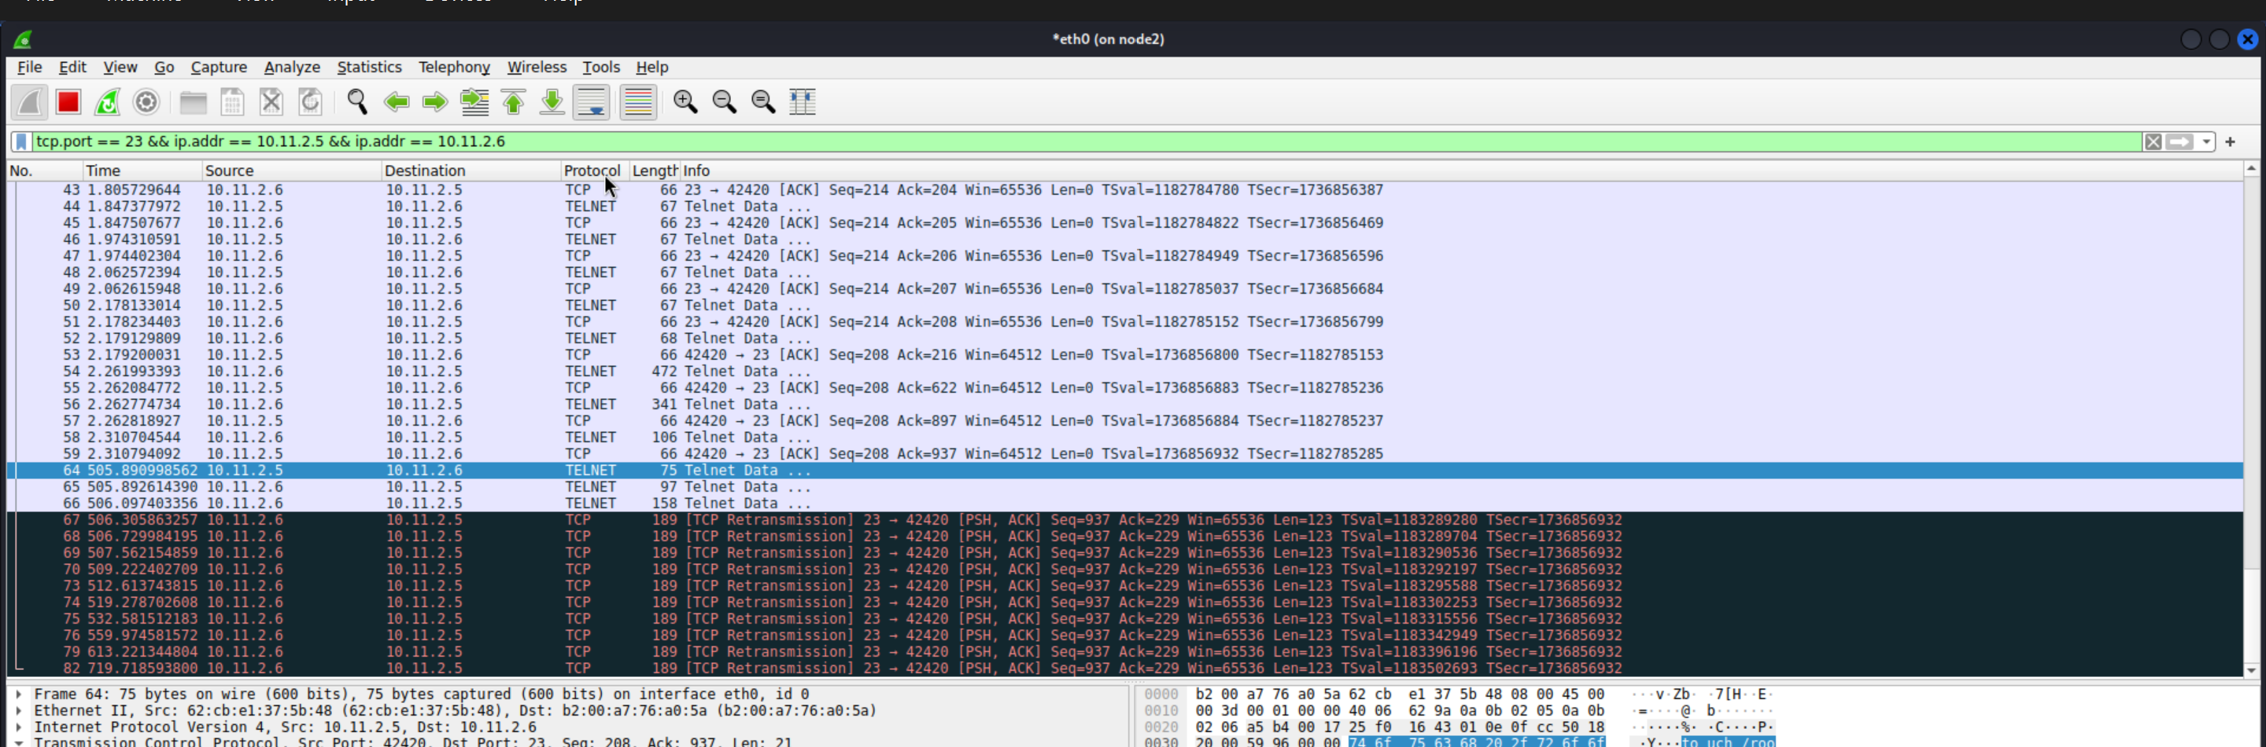
Figure 11. Injected Telnet packet with a 21-byte command payload.
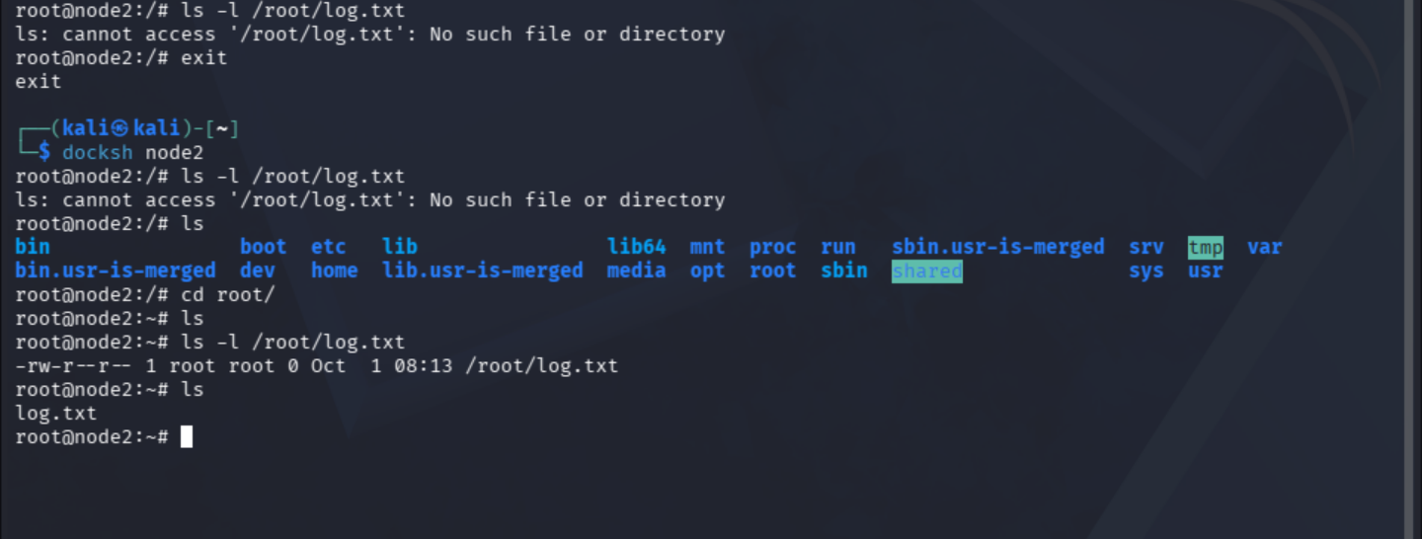
Figure 12. Node2 lists /root/log.txt after the injection.
For the controlled reverse-shell test, node3 listened on TCP port 4444 while node1's Telnet session remained open. The forged Telnet command made node2 connect back to node3. The listener showed a root@node2 prompt, hostname returned node2, and id reported uid=0(root).
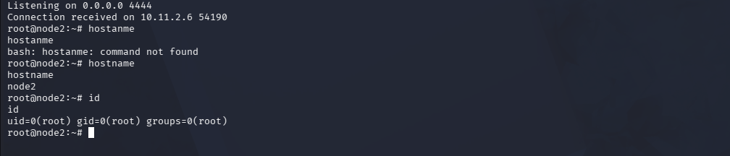
Figure 13. Node3's listener receives the node2 shell and confirms its identity.

5. AI-assisted real-time attack detection
Key prompts. I gave the AI tool the Task 5 requirements and asked, “Now create a script for Task 5,” followed by, “Ok walk me through from start to end for Task 5.” I checked the proposed detection logic against the three earlier attacks, then ran tcp_attack_detector.py on node2’s eth0 interface.
Attack | Detection approach | Observed result
SYN flood | Count SYNs and unfinished handshakes in five-second windows. Alert at 20. | Alerts at 20 and 170 SYNs from the same number of source IPs. Pending connections reached 455.
SSH RST | Check the Ethernet source and TCP timestamp against the SSH connection. | SUSPICIOUS SSH RST: Flagged a RST from port 58738 with a different Ethernet source and no timestamp.
Telnet injection | Check Telnet data for those differences and the file creation command. | POSSIBLE TELNET INJECTION: Flagged a 21-byte packet on port 41914 with both differences and the command marker.

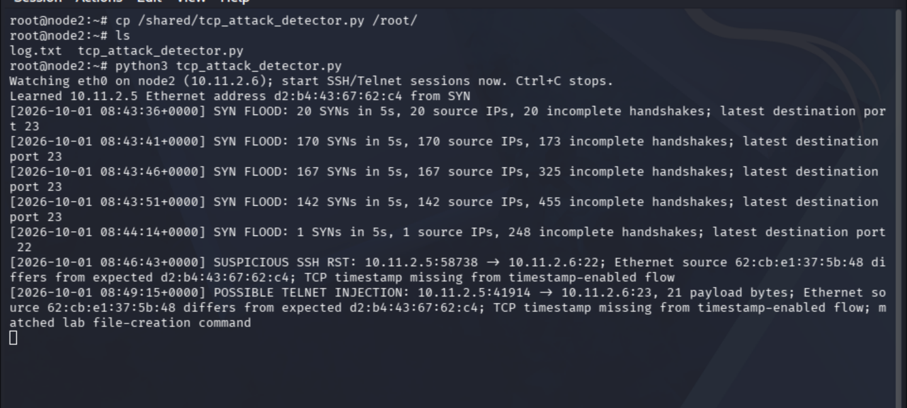
Figure 14. Node2 detector output contains all three alert classes.
Assessment. The detector raised real-time alerts for all three attacks tested in the lab. Its pending-flow count is an estimate and may differ from the kernel’s SYN-RECV count. The SSH and Telnet alerts also need context because Ethernet addresses can change, legitimate RSTs occur, and an authorized user could type the same Telnet command. The command check only works when the traffic is visible as plaintext.

